**Form 12BB**

The Central Board of Direct Taxes (CBDT) has introduced a new Form 12BB. This form, applicable from June 1, 2016, will act as a single entity that you can use to declare your investments and claim tax deductions under HRA, LTA, Section 80, and interest paid on home loans under Section 24 of the I-T Act.

## What is Form-12 BB?

Every year salaried employees furnish an investment declaration to their employer in respect of Income Tax Deduction they are eligible under different sections of Income Tax Act along with supporting evidences. This declaration is required by the employer in order to calculate TDS to be deducted on Salary of the employee. Up Until now there was no standard format for investment declaration. But, now as per New Income Tax Rule 26C the employees are required to furnish the details and evidences of the claims or deductions to the employer in Prescribed Form 12BB.And the same is to be considered by all the employers while calculating the TDS liability of the employees. New Rule 26C is applicable from 1st June, 2016.

The below details are part of the new Income Tax Rule 26C. Form 12BB has to be submitted by employees to their employers in relation to:

**House Rent Allowance**: House Rent Allowance is exempt under section 10 (13A) of the Income Tax Act. To claim HRA, you have to provide documentary evidence i.e., Rent receipts. You also have to provide details of landlord (name & address) and the amount paid as rent. [Permanent Account Number](http://www.relakhs.com/pan-as-identity-proof-misuse/) (PAN) of the landlord shall be furnished if the aggregate rent paid during the year exceeds one lakh rupees.

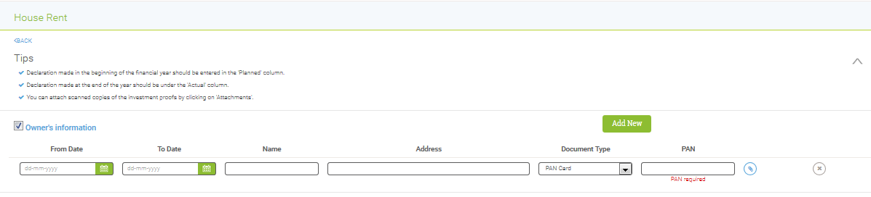

**Interest Payments on Home Loans:** To claim income tax deduction under section 24 on home loan interest payments, you have to furnish details of interest amount payable/paid, lender’s name & address & PAN number of the lender in Form 12BB. (Read: ‘[Income from House Property & Income Tax Benefits](http://www.relakhs.com/understanding-tax-implications-of-income-from-house-property/)‘)

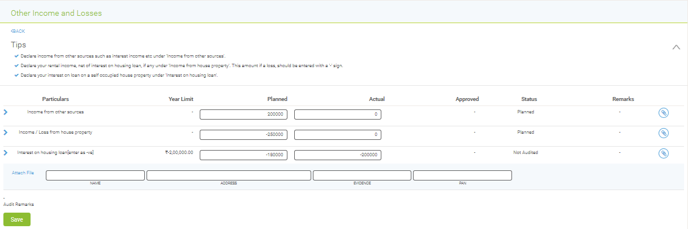

**Income Tax Deductions under Chapter VI –A:** You have to provide the details & evidences of your investments or expenditures related to various sections like 80C, 80CCC, 80CCD, 80D (medical insurance premium), 80E (deduction of interest on education loan), 80G (donations).

**How to Generate Form 12BB in Paybooks Application (Green ESS)**

**Step: 1** Click on Dropdown in the Dashboard menu.

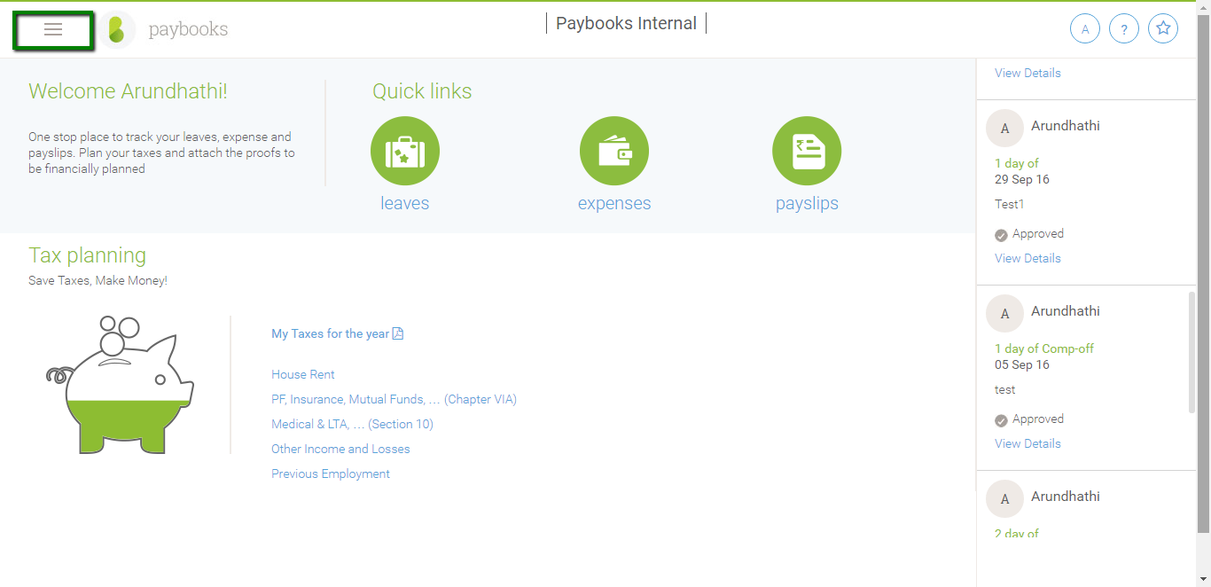

**Step: 2** Click on Reports in the Dropdown menu.

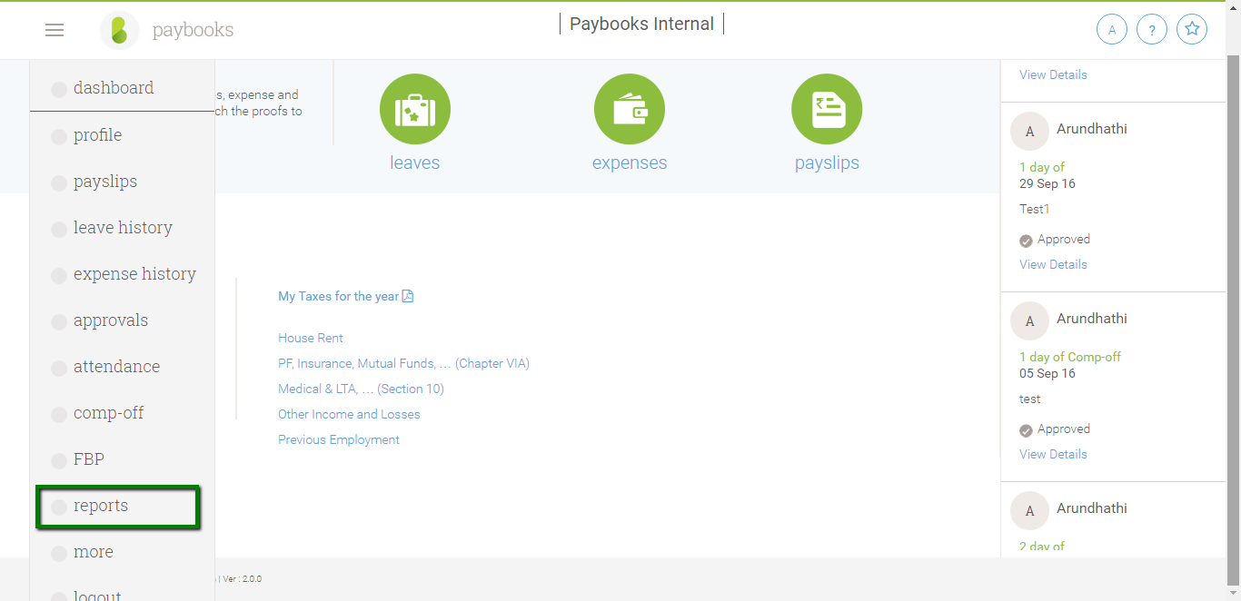

**Step: 3** Click on Actual. By clicking Actual, your Form 12BB gets downloaded.

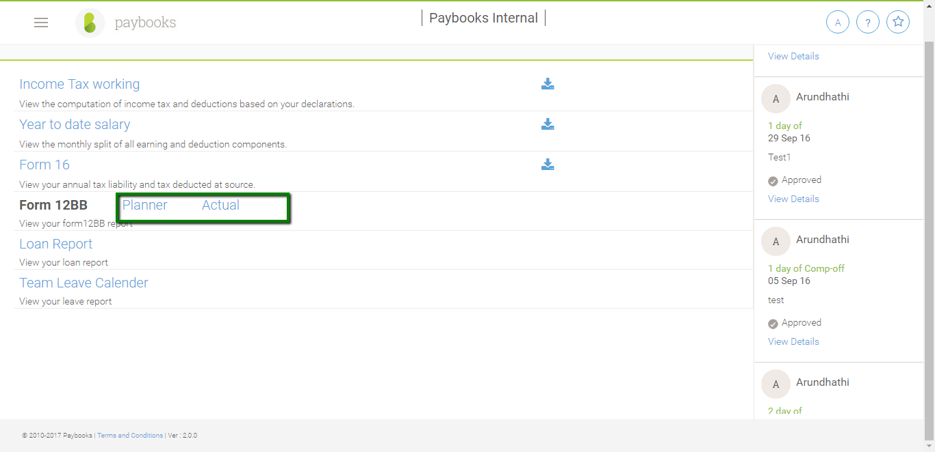

**Step: 4** The Copy of Form 12BB Downloaded in PDF format from the Application.

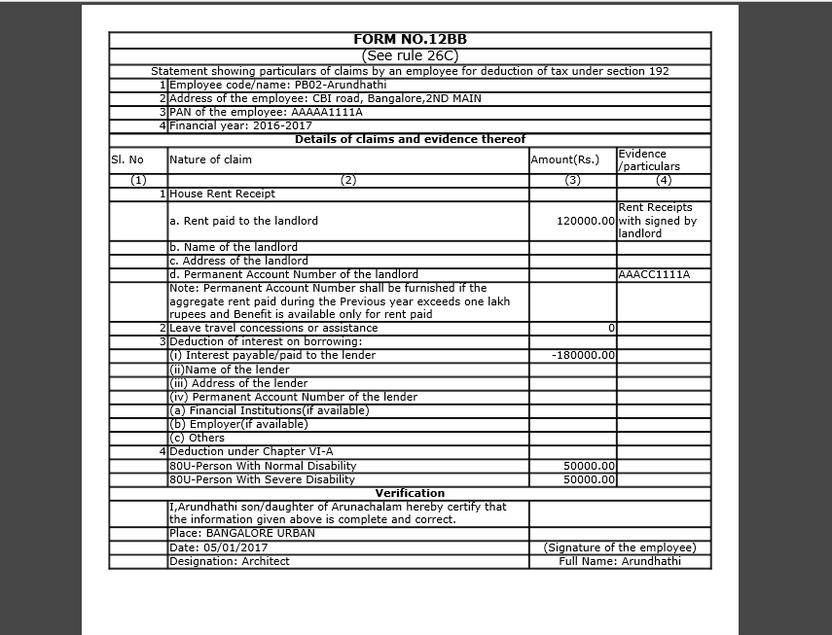

**Step: 4** You need to take printout of your Form 12BB, Sign and submit to your HR/Finance department.

**Thank You**